Nov. 15, 2015

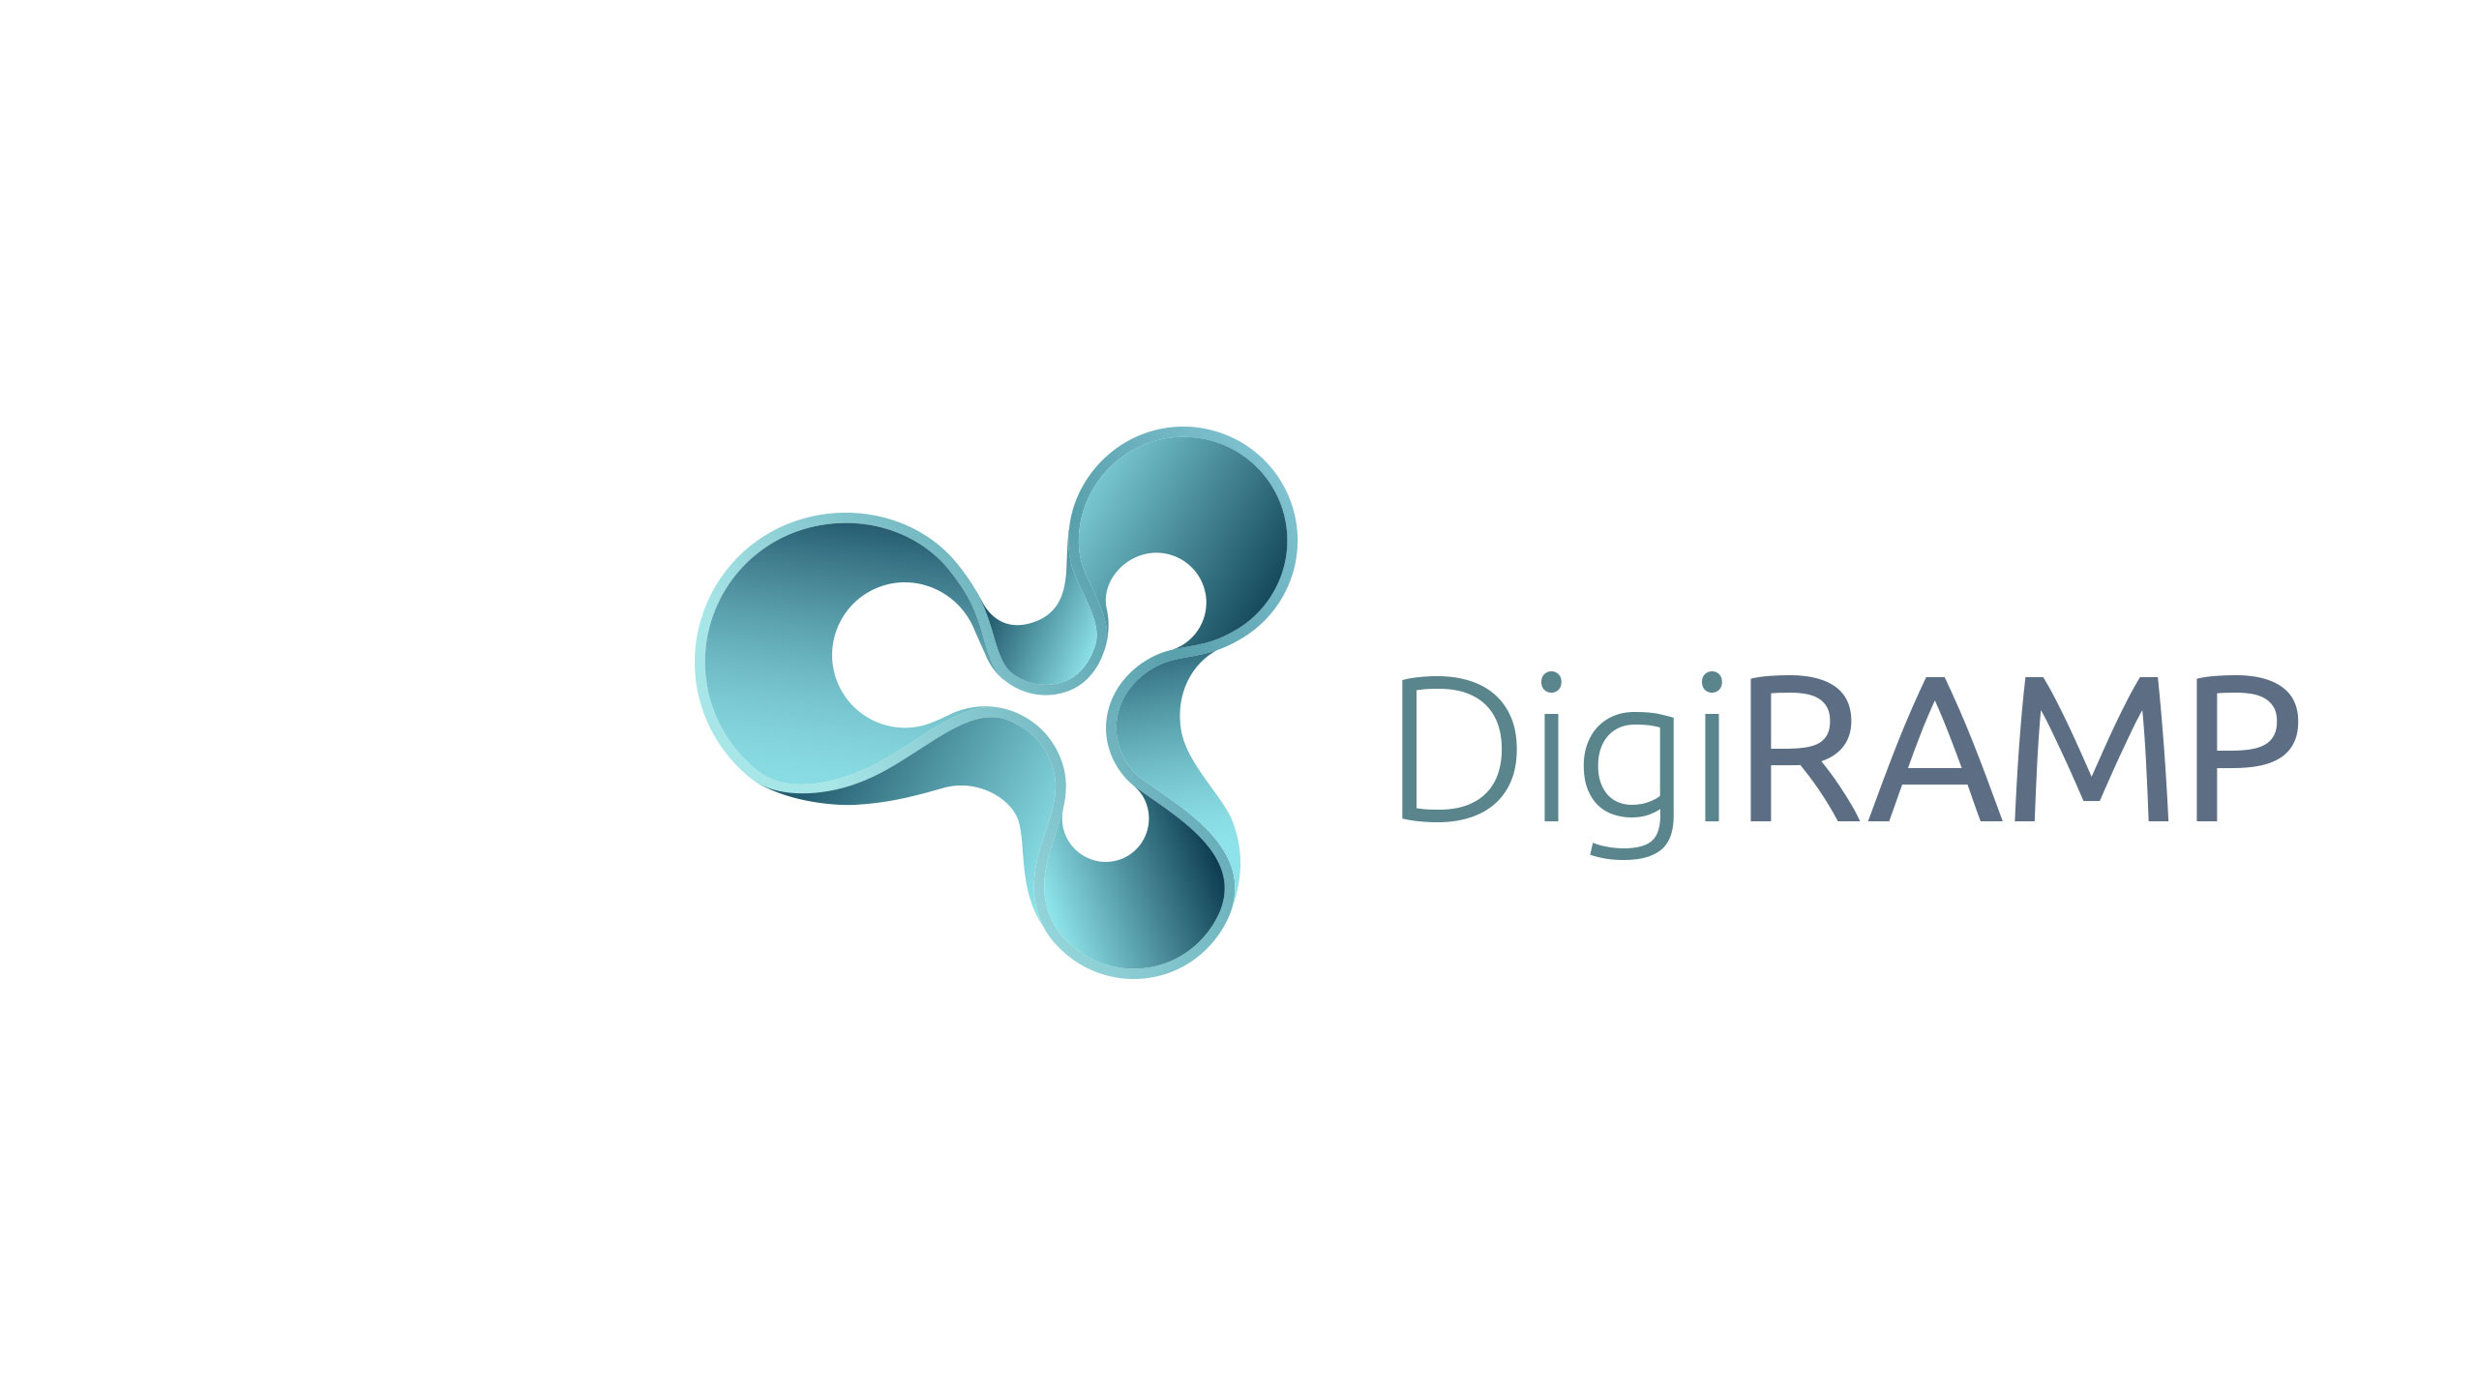
10713 Burbank Blvd. • North Hollywood CA 91601 • (818) 753-9300 t. • (818) 753-9966

DigiRAMP - Corporate Structure

Founders:

Peter Rafelson
10713 Burbank Blvd.
North Hollywood, CA
USA
91601

Max Grønlund
Kærkøkken 3c
8520 Lystrup
Denmark
CPR: 2003630253

Corporate/Legal

- Certificate of Incorporation
- Action of Incorporation
- Bylaws
- Unanimous Written Consent of Directors in Lieu of Organizational Meeting
- Founder's stock purchase agreements
- Stock option plan and form stock option agreement
- Indemnification agreements for directors
- Proprietary information and assignment of inventions and IP agreements
- IRS Form SS-4, Application for Employer Identification Number
- California state qualification
- S.A.F.E. agreement(s)
- Forms of NDA, employee offer letter, and consulting agreement
- Capitalization table and stock certificates

Options:
IP Holding company vs. direct Corp?
Individual Founders – Holding company vs. Corp. Shareholder
Engagement of loan-out services vs. employment – (legal vs. tax?)

Max Grønlund will relocate to Los Angeles as soon as possible – will need working visa and application for Green Card. Needs to resolve any tax issues in Denmark. Possibly can use contribution of IP to Corp as equity and immigration status

Q: How does a non-US citizen co-own /co-found
EB-5?

Physical Operations
DigiRAMP will lease office space at RMC Studios in N. Hollywood
Business License

Additional Admin:
Banking/Lines of Credit/
Insurance, (Health) Benefits, E&O
CPA, Book Keeping, Payroll

Compliance:
Government requirements (e.g., unemployment insurance, worker’s compensation, OSHA, payroll tax requirements, self-employment taxes, etc.).

